Action or Romance? Which genre is "better"

The dataset is consisting of 5,000 movies extracted from IMDB. This dataset has information about the directors, actors, budgets, gross, Facebook likes, etc... As an action film fan, the goal of this project is to analyze several categories of Action and Romance movies, to determine if the Action Genre is "better" than the Romance Genre.

*The two main questions to look after:*

1. Which genre has more popularity?
2. Which genre is more profitable?

**The Popularity Contest**

In order to determine the popularity of each genre, my analysis is divided into two parts:

1. Number of Production
2. Public Recognition

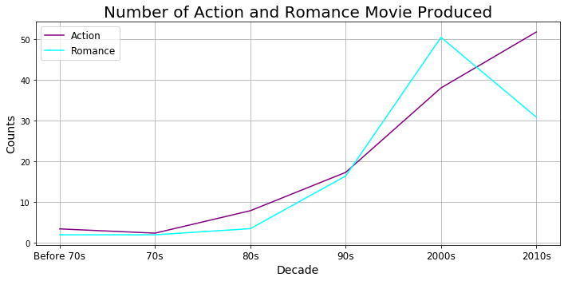

The above graph shows the number of Action and Romance movies produced for each decade. As shown from the graph, Romance movies’ production from year 90s to 2000s jumped from roughly **16 movies per year** to **51 movies** **per year** but lost significant amount of production after 2010s, which dropped down to **32 movies per year**. Whereas for Action movies, the number of movies produced increase to around **53 movies per year** in the end. Action genre of movies is growing at a steady rate which surpassed Romance movies in production numbers by a significant amount.

These three graphs compare the number of Facebook likes, critic reviews, and user reviews:

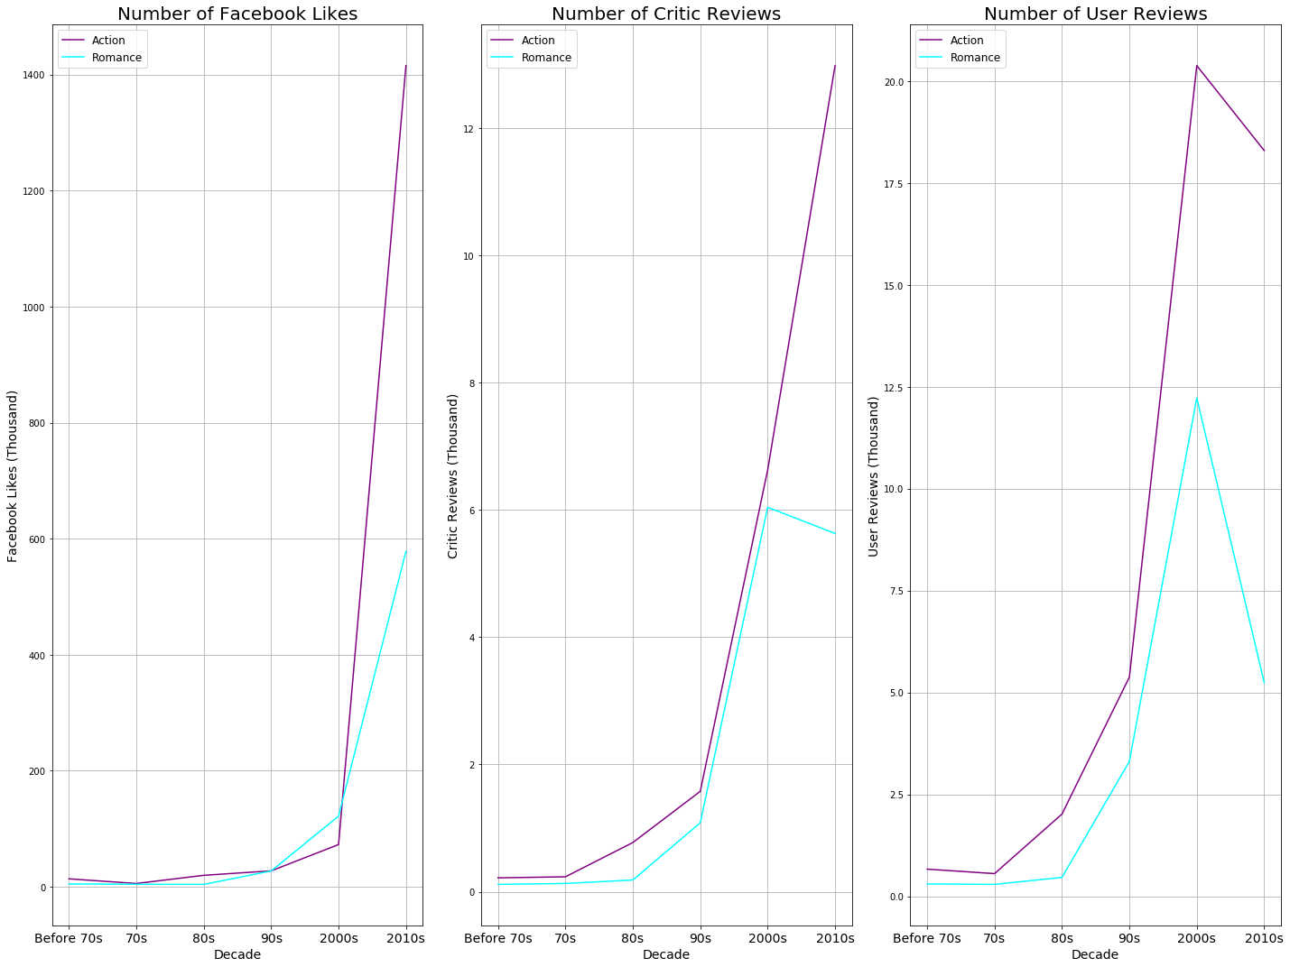

As shown above, the graphs disclose that in terms of public recognition, Action movies has Romance movies beat by a huge margin from all three categories. Especially in Facebook Likes, Action movies has more than **1.4 million** likes in comparison to Romance movies’ **less than 600,000** likes. All three categories, Action movies has double the user reviews and likes.

From the analysis, we can see that Action Movies are more interested by the public and the producers are willing to increase their production number. In the recent decades, Action Movies are more popular than the Romance movies, and the gap seems to be widening.

**Where is the money at?**

Although public recognition is important when it comes to determine a good movie, however another important factor is the profitability. If a movie’s box office revenues are profitable, it must mean that people are willing to pay to watch it. Intuitively, from the previous analysis of popularity, we can easily assume that Action movies should be more profitable than Romance movies consider the difference in production numbers. Is this always true?

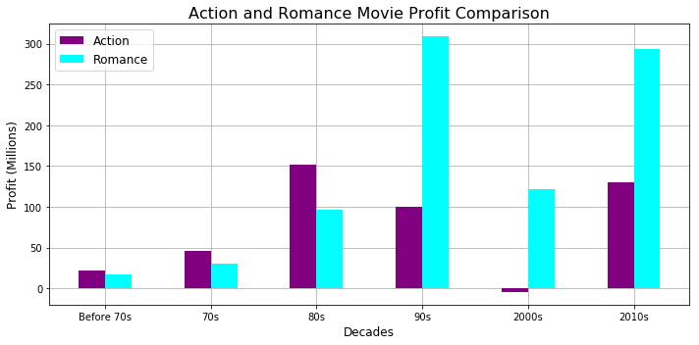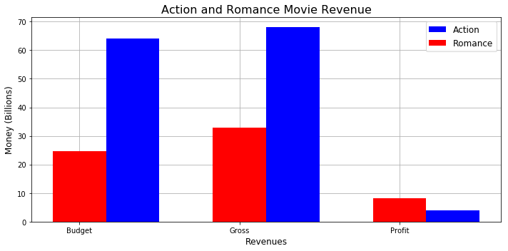

Shocking results! Although the Action movies seemed to be more popular with the popular with the crowd, it seems to be less profitable. On the bar graph on the left, Action movies have significantly less profit than Romance movies from the last three decades. Especially from **2000 to 2010**, Action movies could not break even.

On the right bar graph, it shows the total budget and gross of each genre. Although Romance genre has double the profitability, it seems that the producers are putting more investment into the Action genre. The budget of Action movies is more than **double** of Romance movies. But is this shocking? The Action genre usually requires better CGI effects, stunt double, big-name actors whereas the Romance genre is more forgiving which really need is a good storyline/plotline.

In the end, the numbers don’t lie. The Romance genre has a better result when it comes to profitability.

**The Distribution of Action and Romance Movies**

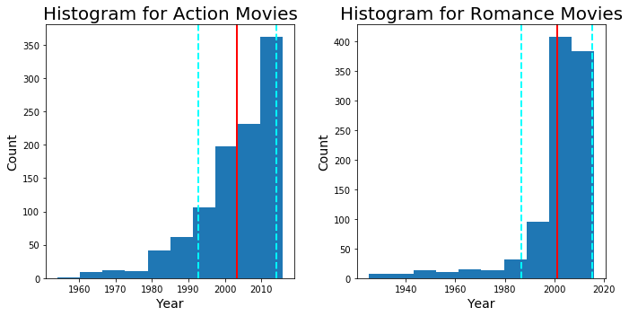

From the two histograms above, we can determine that most movies are produces around year 2000 since the majority (roughly 70%) of movies cluster around the **mean (red line)** and within the **first standard deviation (blue lines)**. In general, movies are becoming easier to produce and more popular in the recent decades.

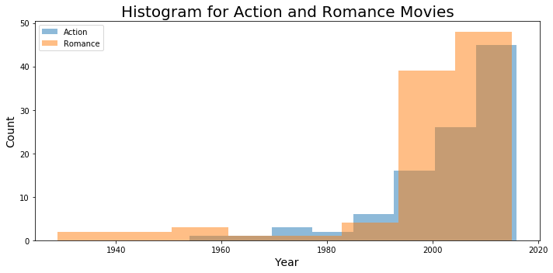

This histogram is generated from randomly pulling 100 movies from each Action and Romance genre. In this histogram, the Romance appears to be more have more production than Action Movies which contradicts the findings from previous analysis. However, this is not the case, as you can see that Romance movies has been around for much longer than Action movies, hence there is a bias.

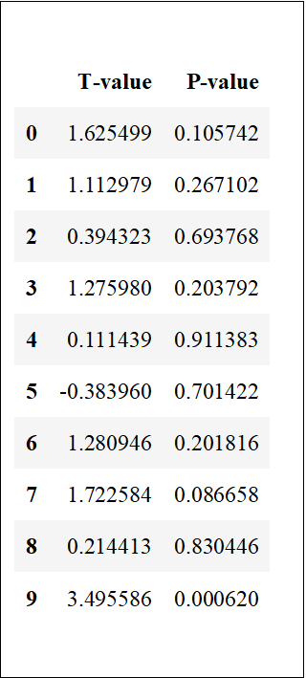This table is generated from running the trial ten times. As you can see from the T-value and P-value, there is a huge variance between each trial. Since the T-value is closer to 0, it means that randomness plays a huge role and the P-value’s inconsistency shows that it is not statically significant.

t-value average is 1.0849790159953032

p-value average is 0.4002748387818058

**Conclusion**

The two genres of movies are similar in strength and weakness, there does not exist an overwhelming advantage consider the data that is currently divides. But what do know is that Action Genre is more popular with the public whereas the Romance Genre is more profitable.

**Future Notes:**

With my current skillset, I am not able to perform a more thorough analysis on this dataset. In the future, I would like to perform more tests on more than two genres and extract more data from IMDB. Increase the factors to compare the genres.